# Sumário

Sumário

Lab: Configure LDAP as Secondary User Store

Training Objective

Business Scenario

High Level Steps

Detailed Instructions

Expected Outcome

By the end of this exercise you should be able to add users to a Secondary User Store configured and login to WSO2 Identity Server using one of the LDAP credentials.

# 

# **Lab: Configure LDAP as Secondary User Store**

## Training Objective

Learn how to add a secondary user store to the platform so that Developers can use their existing credentials to login and use WSO2 API Manager.

## Business Scenario

PizzaShack wants accelerate its digital transformation by providing an API Management platform to its developers.

## High Level Steps

* Configuring Apache Directory Studio as a Secondary User Store.

### Detailed Instructions

Follow the steps at [1] to add an application creation workflow.

1. Log in to the management console and click Add under the User Stores submenu in the Main menu.
2. The Add New User Store page opens.
3. In the User Store Manager Class list, select the type of user store you are creating.
   1. Choose Use ReadWriteLDAPUserStoreManager for LDAP user stores to do both read and write operations.
4. Enter a unique domain name with no underscore (_) characters, and optionally enter a description for this user store:
   1. Type: <a nice domain name>
5. Enter values for the properties, using the descriptions in the Descriptions column for guidance.

|  |  |
| --- | --- |
| **Property** | **Value** |
| Connection URL | ldap://wso2is-as-km-service:10389 |
| Connection Name | uid=admin,ou=system |
| Connection Password | admin |
| User Search Base | ou=Users,dc=wso2,dc=org |
| User Entry Object Class | identityPerson |
| Group Search Base | ou=Groups,dc=wso2,dc=org |

1. Example

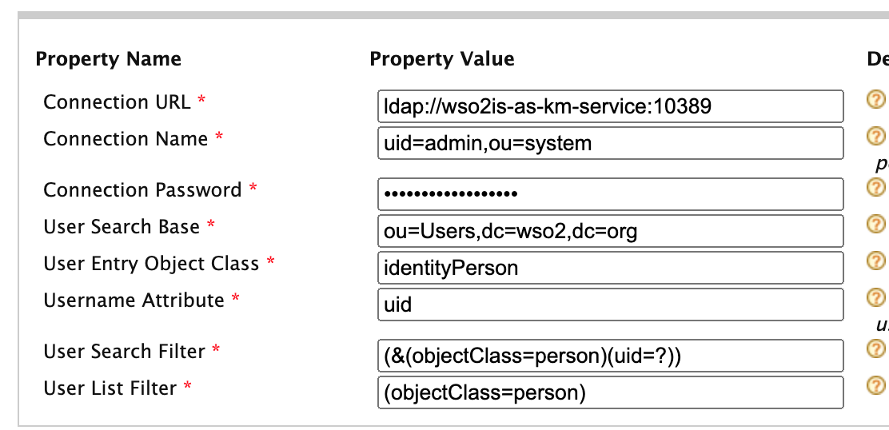

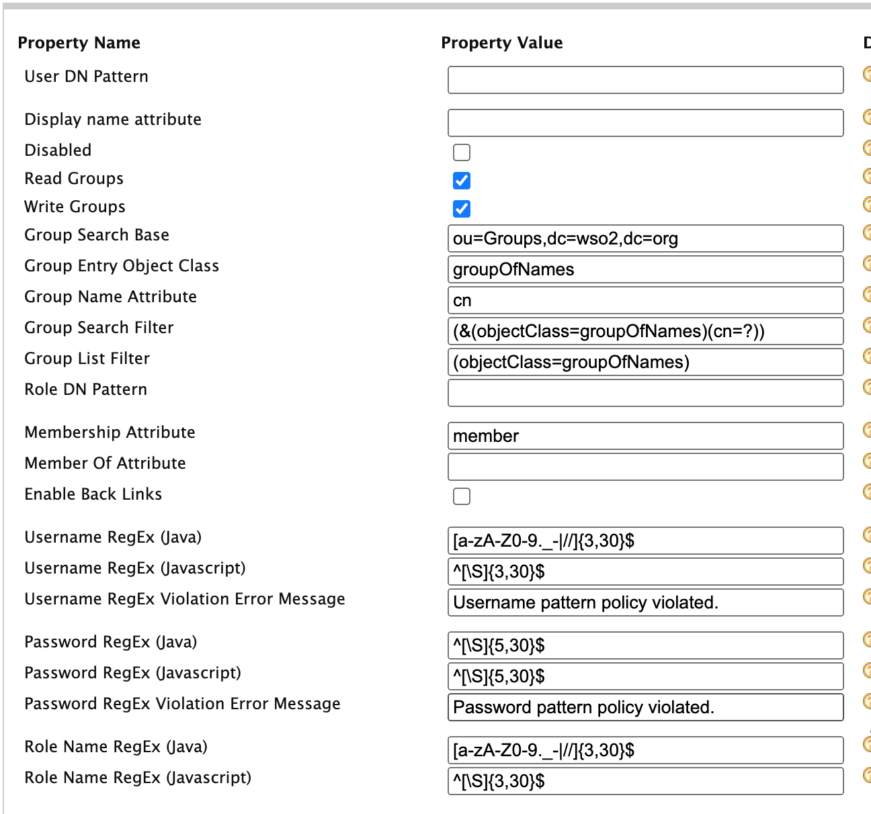

1. Validate your configuration by listing users. Click List under “User and Roles” and then select “Users”. You should see a list of employees pre defined by WSO2 Instructor, like the image bellow:
2. Add a new user and assign all Internal roles to it
3. Login to both Publisher and Store using the newly created user

## Expected Outcome

# By the end of this exercise you should be able to add users to a Secondary User Store configured and login to WSO2 Identity Server using one of the LDAP credentials.